Spacious luxury apartment, Mijas Golf, Costa del Sol



(Have you clicked on all the pictures on the website?)

El Limonar de Mijas Golf is a quiet complex, which was finished in 2003. Complete with gardens and swimming pool, it is located in the heart of Mijas Golf, which boasts two championship golf courses, Los Lagos and Los Olivos. El Limonar is about 20 minutes drive from Malaga airport and the cosmopolitan resorts of Marbella and Puerto Banus, and 10 minutes from the nearby La Cala and Fuengirola, both of which have numerous shops, bars, restaurants and beaches. Mijas is a traditional whitewashed village, 5 mins drive from the apartment, set in the mountainside, overlooking the countryside and sea. The nearest beach is 4 kilometers (2.5 miles).

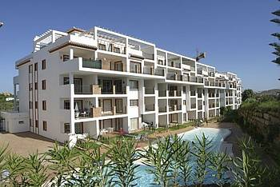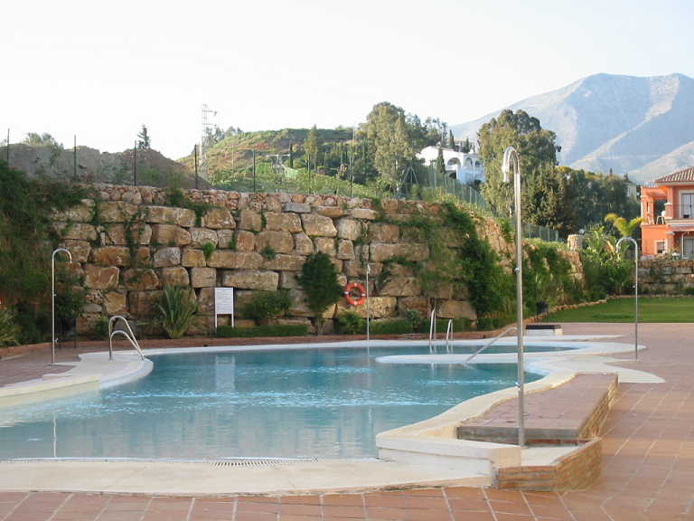

The complex is located next to the third fairway of Los Lagos and is just minutes from the beautiful 5 star Hotel Byblos, which offers superb restaurants, tennis courts, and a Thalassotherapy Centre. There are activities for all the family in close proximity to the complex. For kids, Tivoli World is a must, a fantastic fun park. The Aqua Park is a superb day out for the whole family and just 5 minutes drive from the complex. Other great attractions for kids are Fuengirola Zoo, Dolphin World, wildlife parks plus many 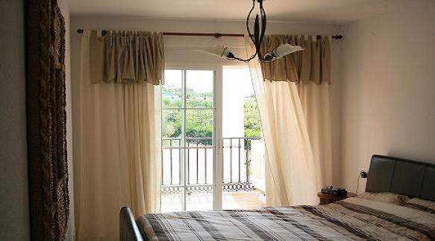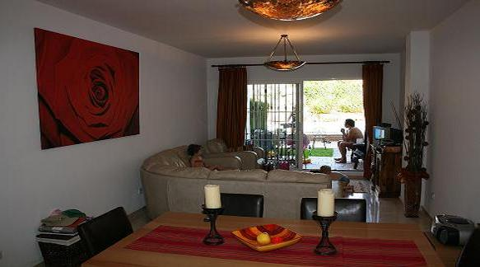many more.

The apartment is finished to a very high standard with marble floors throughout and is fully air-conditioned. The lounge diner features leather sofas, dining table and 6 chairs with direct access to the patio, overlooking the private shared pool. Two large double bedrooms open onto a sun terrace, as does the lounge/dining room. The kitchen is well equipped with a dishwasher, fridge freezer, washing machine and microwave. It has secure videophone access and an underground parking space.

The main bedroom has a king size double bed, with ample wardrobe space (including a safe) and an en-suite marble tiled bathroom (with whirlpool bath and overhead shower). The second bedroom has two single beds that can zip and link together to form a king size double bed. Again there is ample storage space. Both bedrooms open onto a sun terrace that overlooks an olive grove, ideal for breakfast! The second bathroom has a shower cubicle and is also marble finished.



The apartment is situated against a backdrop of picturesque rolling hills and a view of the old village of Mijas. A visit to Mijas will reward guests with the experience of true Spanish culture at its best. Local Fincas in the region serve some excellent food and wine and provide guests with the opportunity sample local produce and meet local people.

A stroll through the white washed streets with their nooks and crannies, the patios, the hermitages… the village conserves the tranquility and enchantment of the past, sheltered by the mountain range and looking out towards the countryside and the sea.

The pueblo of Mijas is a very pleasant mix of traditional Spanish town and international resort with nightclubs, restaurants, etc for all tastes. Mijas is located on a wooded mountainside with stunning views from Malaga to Gibraltar. From here you can make day trips to Marbella, Puerto Banus, Rhonda, Granada, Seville and Malaga.

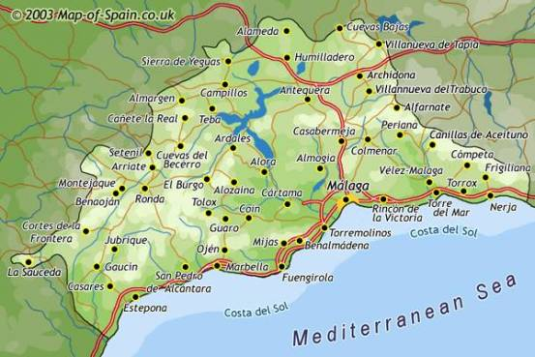

The apartment with its location is ideal for a lazy or active holiday or to explore the local area. Please note we only let to friends, family and colleagues. The apartment caters for four, however please do let us know if your party is for six, camp beds are available as well as a child cot. Bed linen, towels and tea towels are provided. Maid service is available. There is a taxi rank on the El Limonar complex should you wish to partake in a few alcoholic beverages in town!
For booking or any questions about the apartment or its location, please phone 07795217712 or email ivoappelmans@hotmail.com. To confirm your booking we will ask for a 50% deposit. The remainder is payable 4 weeks before your holiday.


1st Jan – 4th May £295
5th May– 1st June £340
2nd June– 31st August £460
1st Sept – 31st December £295

Average monthly temperature

Please note peak rate of £460 per week applies for Easter, Christmas, New Year and any UK bank holidays. The above are highly competitive rates; typically high season rates start from £450 per week. Cost is:
Based on the apartment and not per person
Based on 7 nights – Saturday to Saturday
Heating is included in winter lets

The small print
Generally the let is from Saturday to Saturday; however shorter and mid-week lets are available, please do let us know. We like to be as flexible as possible!
You can access the apartment at 3pm on the day of arrival, please vacate the apartment by 10am on your departure date – this allows a full clean before our next guests arrive. There are numerous bars and restaurants at the golf club house and the Byblos hotel should you need to wait for your flights.
If you would like to explore the local area you may like to hire a car. Should you not wish to hire a car, a taxi from Malaga airport to El Limonar will cost about £20. There are always taxis outside the airport; alternatively we can arrange for a driver to meet you at little extra cost. You can also take the train from the airport to Fuengirola (cost about £3) and then get a taxi to the apartment. There is a 24-hour taxi rank at the El Limonar complex.
If you break any cups, glasses, plates please replace them. If you break or damage any larger items please let us know, we will ask you to pay for the damage as we will need to replace / repair for future guests.
We request that you not smoke in the apartment or bring your pets along!

Useful web sites:

http://www.mijas.es
http://www.golfholidaysonline.com/mijas_golf_club.html
http://www.andalucia.com/travel/airports/malaga.htm
http://www.ghotw.com/generic_hotel.cfm.cfm/id/956.htm (Map)
http://www.visitcostadelsol.com/
http://www.buzz-carhire.com/malaga-airport-car-hire.asp
http://www.cheapflights.co.uk
http://www.mijasgolf.org/paginasing/presentacion.html

